**Assignment 4**

**IPL Matches**

**Que 1:** Load and display the first five records of the IPL matches dataset

**Ans:**

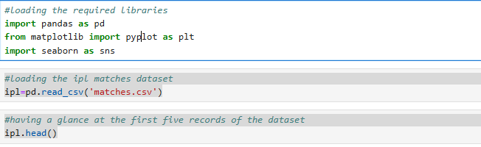

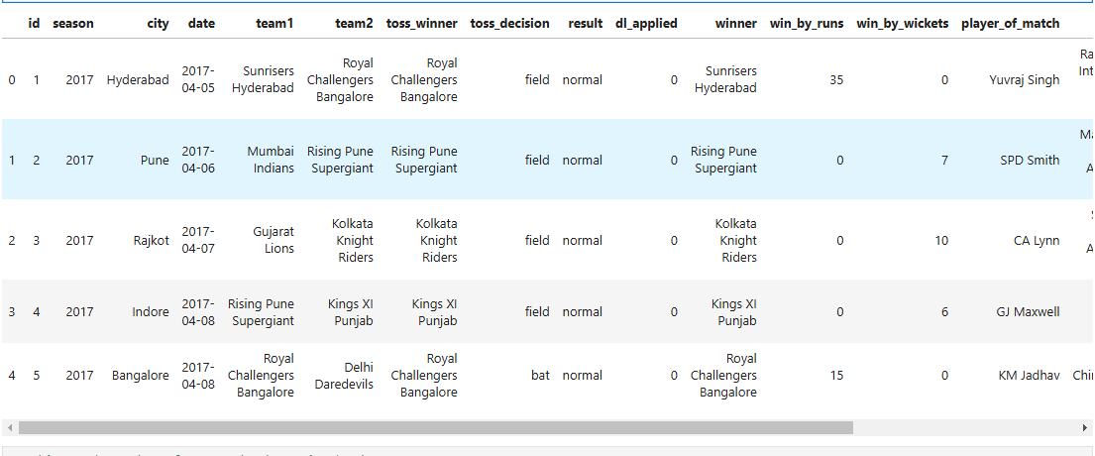

**Que 2:** Display the number of rows and columns in the IPL matches dataset

**Ans:**



**Que 3:** Display the distribution of players who have been awarded "Player of the Match" in the IPL matches dataset

**Ans:**

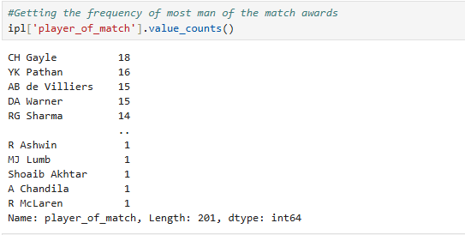

**Que 4:** Display the top 10 players who have won the "Player of the Match" award the most in the IPL matches dataset

**Ans:**

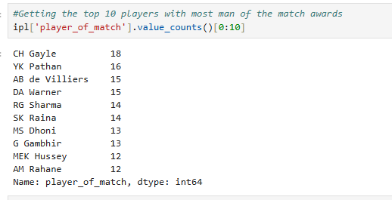

**Que 5 :** Display the top 5 players who have won the "Player of the Match" award the most in the IPL matches dataset

**Ans:**

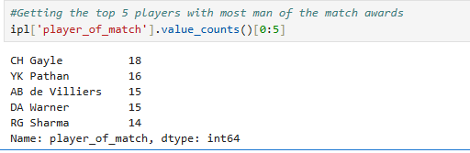

**Que 6:** Create a bar chart displaying the top 5 players who have won the "Player of the Match" award the most in the IPL matches dataset

**Ans:**



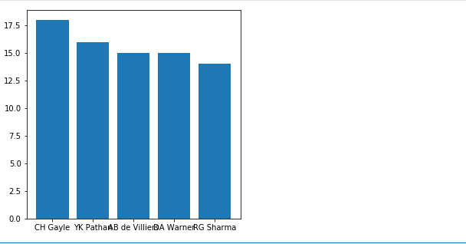

**Que 7:** Display the distribution of match outcomes (e.g., win, loss) in the IPL matches dataset

**Ans:**

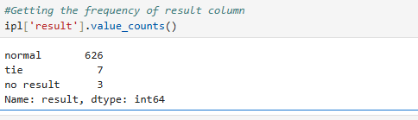

**Que 8:** Display the distribution of teams that won the toss in the IPL matches dataset

**Ans:**

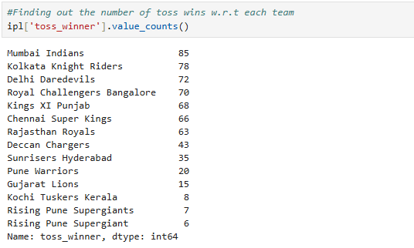

**Que 9:** Filter the IPL matches dataset to display the records of matches where the winning team won by runs, and view the first few entries

**Ans:**

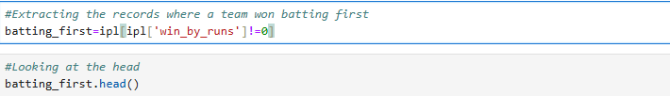

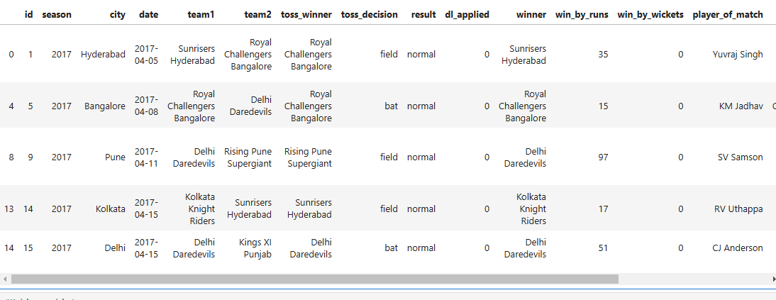

**Que 10:** Create a histogram showing the distribution of the number of runs by which the winning team won in matches where the team won by runs

**Ans:**

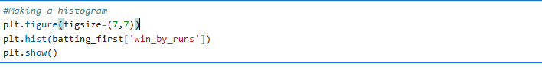

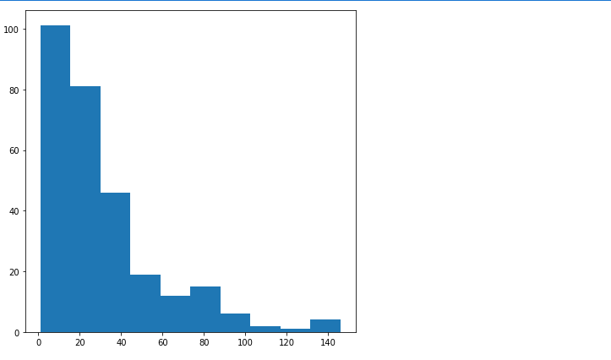

**Que 11:** Display the distribution of teams that won in matches where the winning team won by runs in the IPL matches dataset

**Ans:**

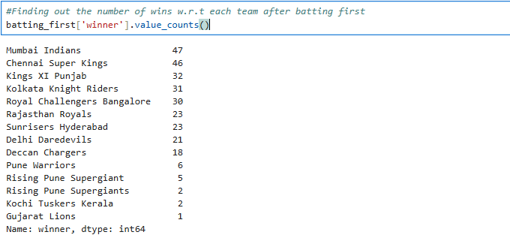

**Que 12:** Create a bar chart displaying the top 3 teams that won by runs in the IPL matches dataset, with each bar in a different color

**Ans:**

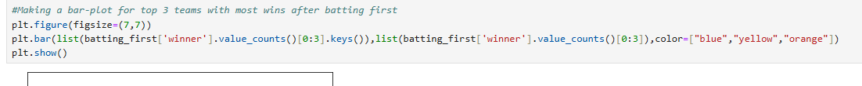

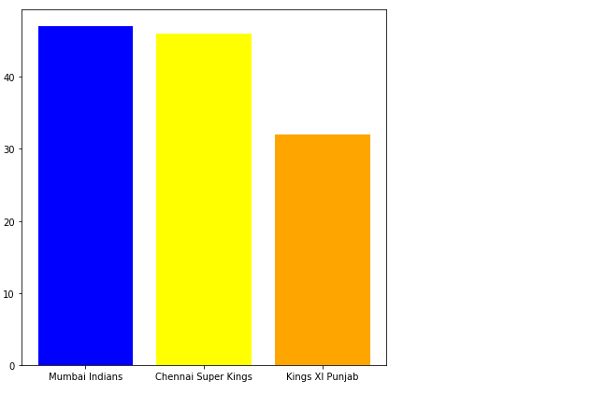

**Que 13:** Create a pie chart displaying the distribution of teams that won by runs in the IPL matches dataset, with percentage labels on each slice

**Ans:**



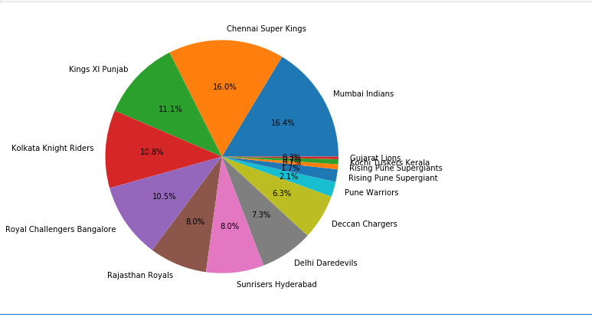

**Que 14:** Filter the IPL matches dataset to display the records of matches where the winning team won by wickets

**Ans:**

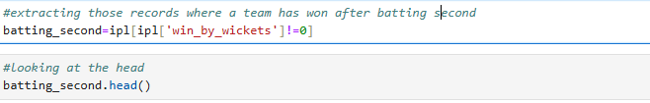

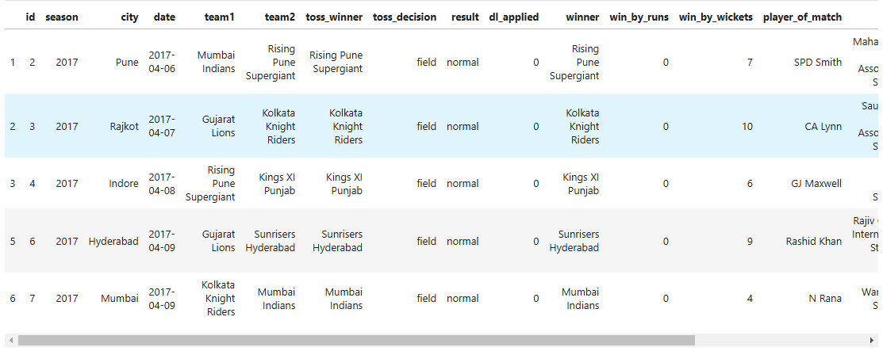

**Que 15:** Create a histogram showing the distribution of the number of wickets by which the winning team won in matches where the team won by wickets

**Ans:**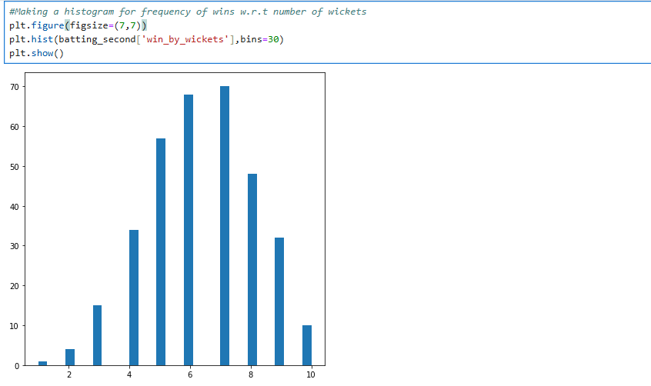

**Que 16:** Display the distribution of teams that won in matches where the winning team won by wickets in the IPL matches dataset

**Ans:**

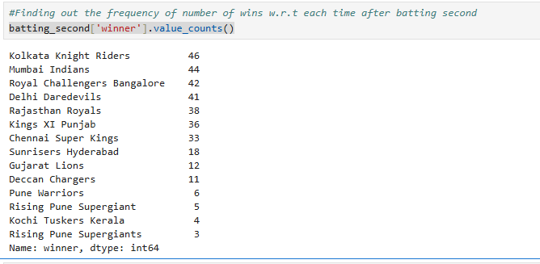

**Que 17:** Create a bar chart displaying the top 3 teams that won by wickets in the IPL matches dataset, with each bar in a different color

**Ans:**

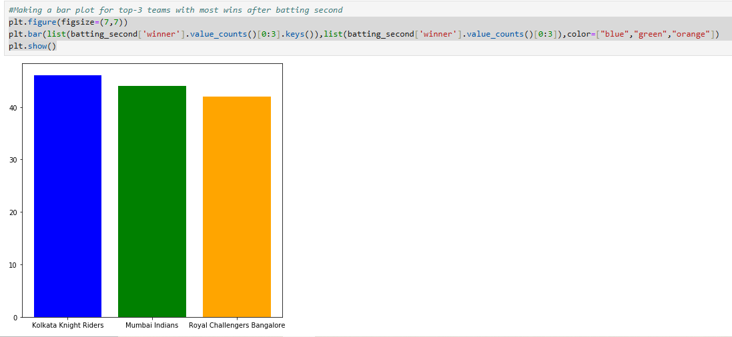

**Que 18:** Create a pie chart displaying the distribution of teams that won by wickets in the IPL matches dataset, with percentage labels on each slice

**Ans:**

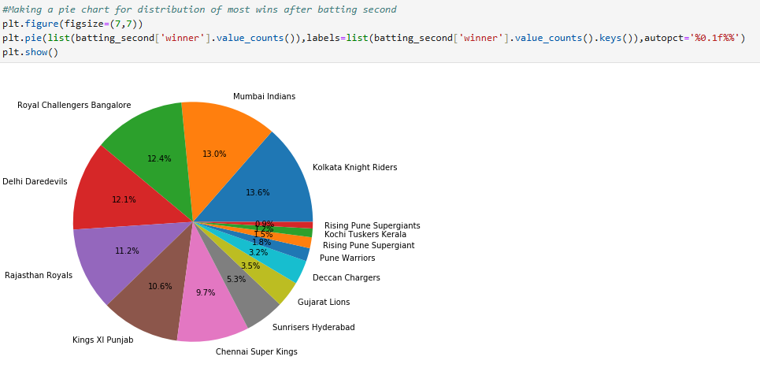

**Que 19:** Display the distribution of matches played in each season of the IPL

**Ans:**

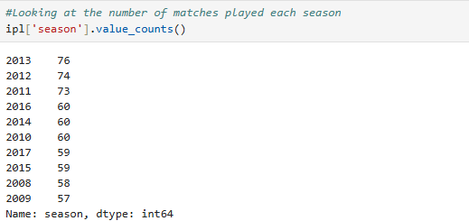

**Que 20:** Display the distribution of matches played in each city in the IPL dataset

**Ans:**



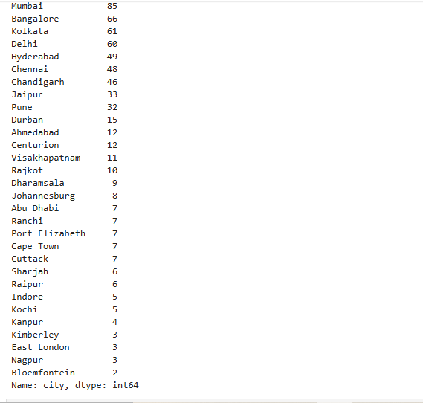

**Que 21:** Calculate the number of matches in the IPL dataset where the team that won the toss also won the match

**Ans:**

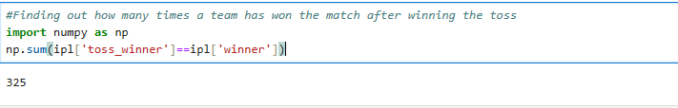

**Que 22:** Calculate the proportion of matches won by the team that won the toss by dividing the number of such matches (325) by the total number of matches (636)

**Ans:**

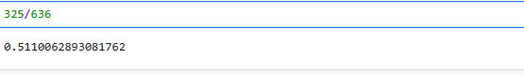

**Que 23:** Load the IPL deliveries dataset and display the first five records

**Ans:**

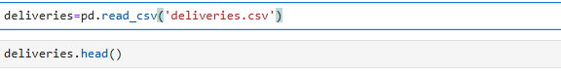

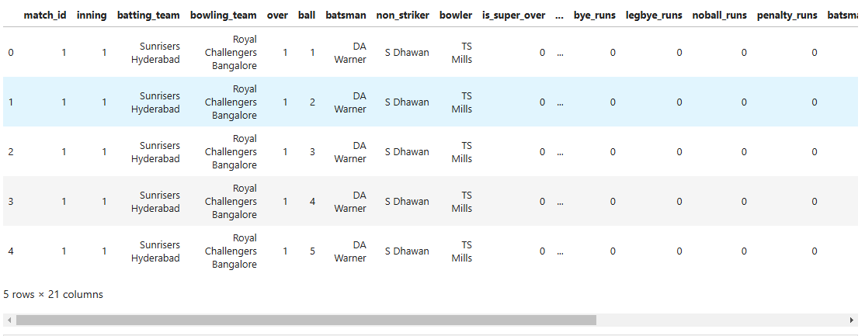

**Que 24:** Display the unique match IDs in the IPL deliveries dataset

**Ans:**



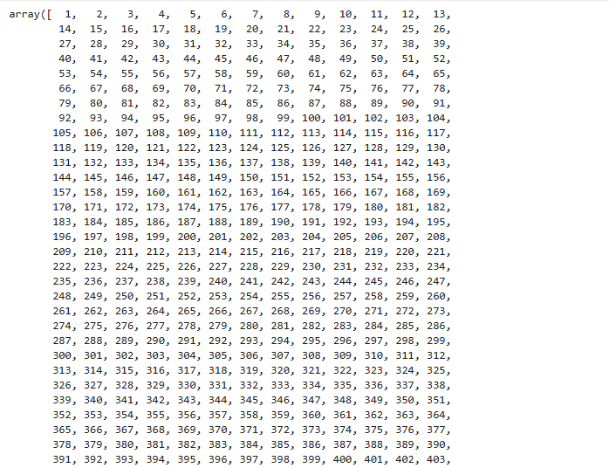

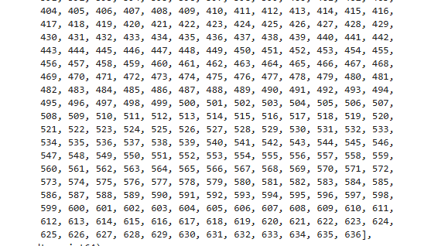

**Que 25:** Display the records of deliveries from match 1 and view the first few entries

**Ans:**

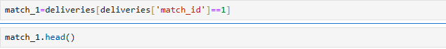

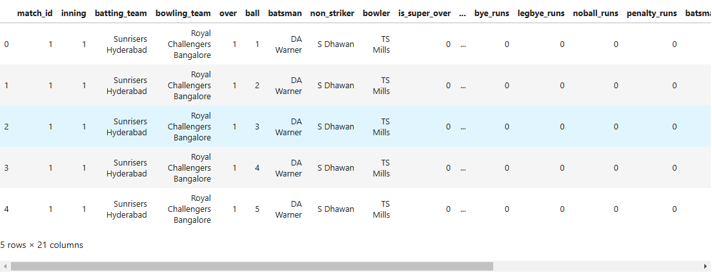

**Que 26:** Display the number of rows and columns in the filtered dataset for match 1 in the IPL deliveries dataset

**Ans:**

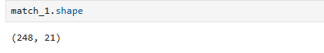

**Que 27:** Filter the deliveries from match 1 where Sunrisers Hyderabad (SRH) batted in the first inning and display the distribution of runs scored by the batsmen

**Ans:**

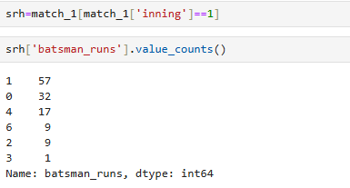

**Que 28:** Display the distribution of types of dismissals for SRH in match 1

**Ans:**

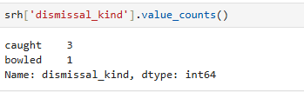

**Que 29:** Filter the deliveries from match 1 where Royal Challengers Bangalore (RCB) batted in the second inning and display the distribution of runs scored by the batsmen

**Ans:**

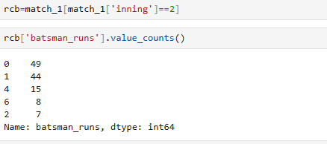

**Que 30:** Display the distribution of types of dismissals for Royal Challengers Bangalore (RCB) in match 1

**Ans:**

